

Assignment #04 – Database Systems

Instructor

Nasreen Akhtar

Session

Spring 2022

Instructions:

- You are required to make a Microsoft Word file, containing all your Queries along with screenshots of every question next to it. Any question without the screenshots will not be accepted. PDF or other format files will not be accepted.
- Keep the questions in order. Not following the proper order will result in marks deduction.
- Word file format should be “Roll-Number_Section_AssignmentNo”, for example 18F-0184_A_Assignment #01. Marks will be deducted for not following the correct format.
- Plagiarism will not be tolerated, either done from the internet or from any fellow classmate and will lead to zero or negative marks in the assignment.
- No late submissions will be accepted.

Part 1 - Joins

Following tasks must be done using Joins. Consider the following three tables. These tables are given in the .txt file attached

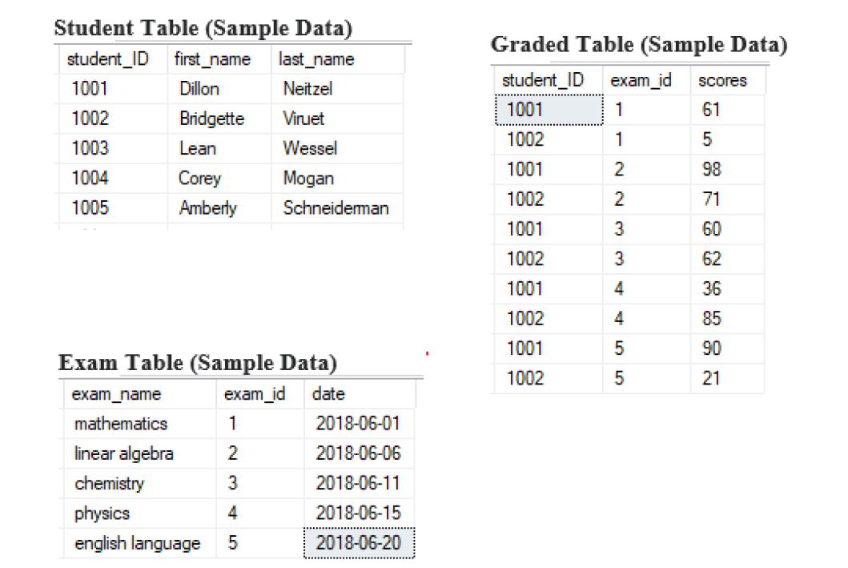

- Enlist students first name and last name in single column (use alias “Top_3_postions”) along with total score for top three students who have the highest total score across all subjects obtained in the exams.
- Write a query to retrieve student ID, exam ID and exam score of those students having exam score less than the average score for that particular exam.
- Write a query to retrieve full name along with student’s exam score of those students who have the highest marks in each of the five exams.
- Enlist details of those students who have not given all the exams, using joins.
- Enlist the details of the exam in which the student “Corey Morgan” scored the highest.

Part 2 - Subqueries

Following tasks must be done using Subqueries. Consider the following tables. You are required to makes these tables (with the data provided) yourself in SQL,

Paintings table,

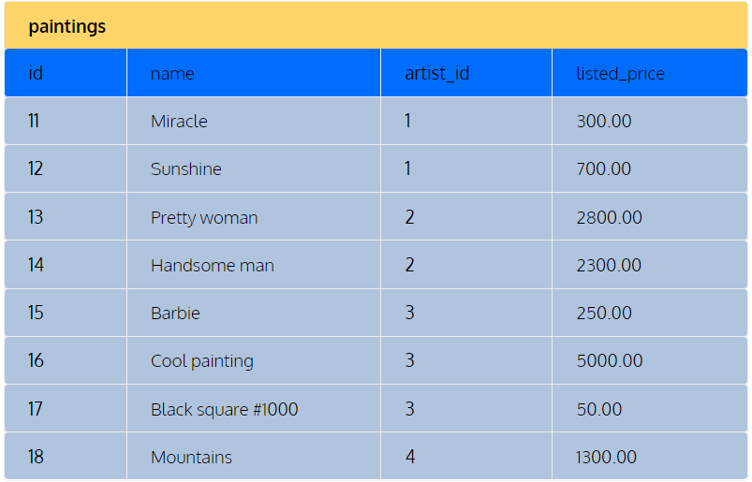

Artists table,

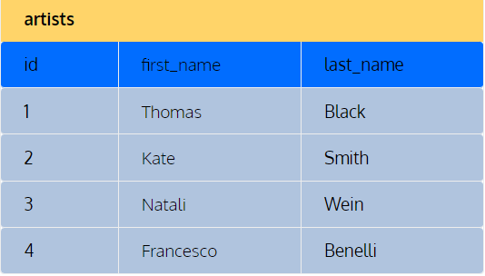

Collectors table,

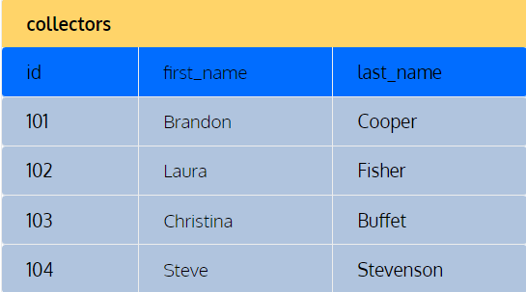

Sales table,

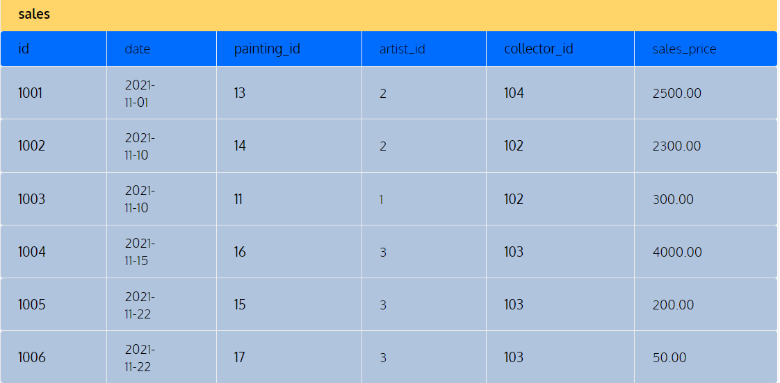

- Enlist name and the price of all the paintings which are priced higher than the average.
- Enlist the full name (single attribute) of all the collectors who have purchased paintings from the gallery.
- Enlist the total amount sales for each artist who has sold at least one painting and order the artists by the total amount, in descending order.
- Enlist the collectors full name and the number of paintings they have purchased through our gallery.
- Enlist the full name of the artists who have had zero sales in our gallery.

